

Follow-up survey

GuildQuality is an independent, unbiased customer surveying company. The company you've hired uses our service to gather your feedback about your experience working with them. Your responses to the confidential survey questions will help them improve the way they do business, improve the way they build, and most importantly, improve the service you receive.

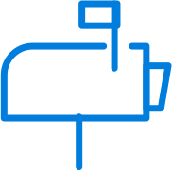

We will first contact you through email. The subject line will say [COMPANY NAME] would appreciate your feedback.

You'll also be contacted by phone. The surveys are short and generally take no more than 3-4 minutes.

In addition, you'll receive a card by mail. Please use the survey access code on the card to complete or view your survey online.

Thanks for your participation in this valuable process.